
Key Stage 4 Curriculum
Economics
When you understand how markets and economies work, you will develop an economic awareness to benefit you personally and professionally for years to come. You can develop communication, critical thinking and analytical skills through tasks based on anything from ways to cut the budget deficit, to weighing up the pros and cons of inflation or being part of free-trade agreements.



By studying GCSE economics students will;
- Understand how markets operate and the roles of consumers, producers or workers within markets
- Understand how the economy works nationally and globally
- Actively engage in the study of economics to develop as effective, self-motivated students, and reflective thinkers
- Understand and apply their economic knowledge and skills, to investigate current and historical economic situations
- Build economic arguments and make informed judgements by using economic concepts and quantitative evidence
- Understand the perspectives of different economic agents including consumers, producers and government in relation to economic activity
- Consider moral and ethical and sustainability issues that arise as a result of the impact of economic activity

Our Learning Journey shows how our topics build upon each other and our students experience a wide variety of themes in order to broaden their learning experience:

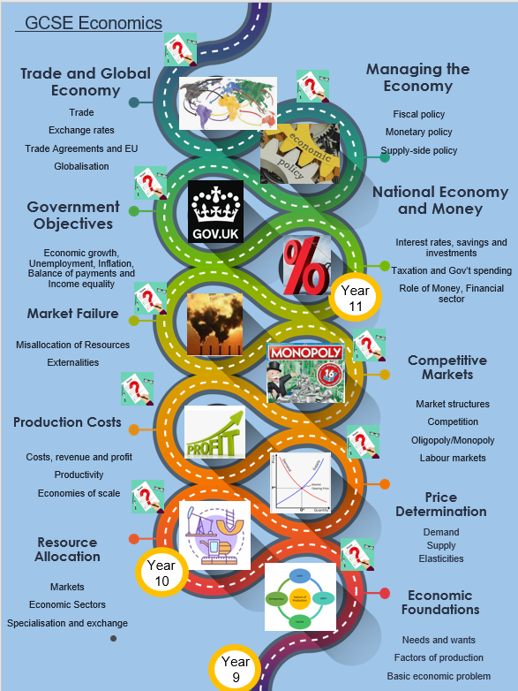

Our curriculum at KS4 is as follows:
Year 10
How markets work:
- Economic foundations
- Resource allocation
- How prices are determined
- Production, costs, revenue and profit
- Competitive and concentrated markets
- Market failure

Year 11
How the economy works:
- Introduction to the national economy, including the role of money and financial markets
- Government objectives
- How the government manages the economy
- International trade and the global economy

Learning through Experiences in Economics
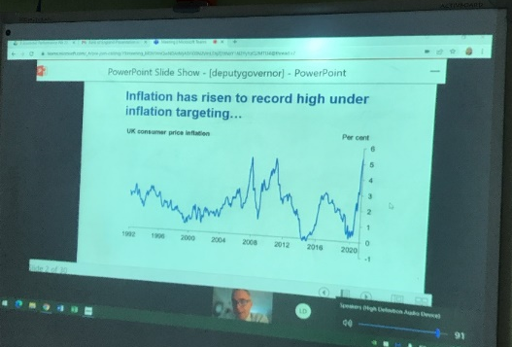
In order to enhance the provision of Economics beyond the curriculum, our students benefit from the following experiences:
- Virtual talk from the governor of the Bank of England
- Visits to the Houses of Parliament
- Getting into the labour market with the Department for Work and Pensions workshop
- Oxfam for Inequality workshop


