
Key Stage 3 Curriculum

Physical Education
Key Stage 3 Physical Education provides students with the opportunity to explore and experience a variety of sports and activities. The key thread throughout our KS3 curriculum is to develop the following three strands of our students;
- “Physical Me” - so they are able to perform all of the sports and activities with confidence and a good degree of technical ability.
- “Leadership Me” – developing students’ abilities to lead sporting activities with confidence.
- “Understanding Me”. – To develop students tactical and technical understanding of all sporting activities covered within the curriculum. Along with developing their understanding of leading healthy and active lifestyles.
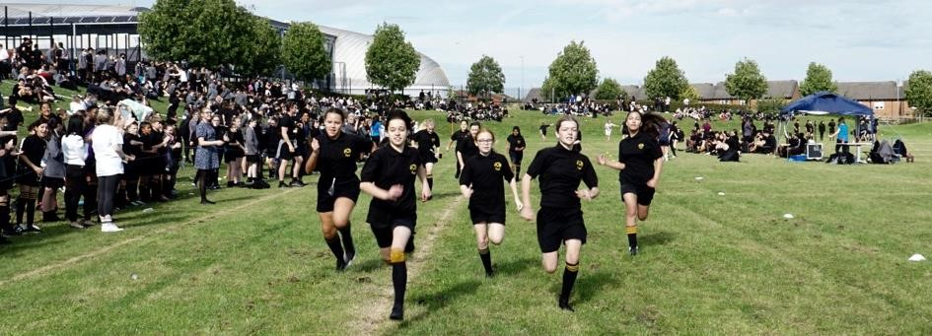
By having a relentless focus on these three strands, we aim to empower our students with the physical literacy to be successful within their Key Stage 4 curriculum and beyond.
"Physical literacy is the motivation, confidence, physical competence, knowledge, and understanding to value and take responsibility for engagement in physical activities for life.”
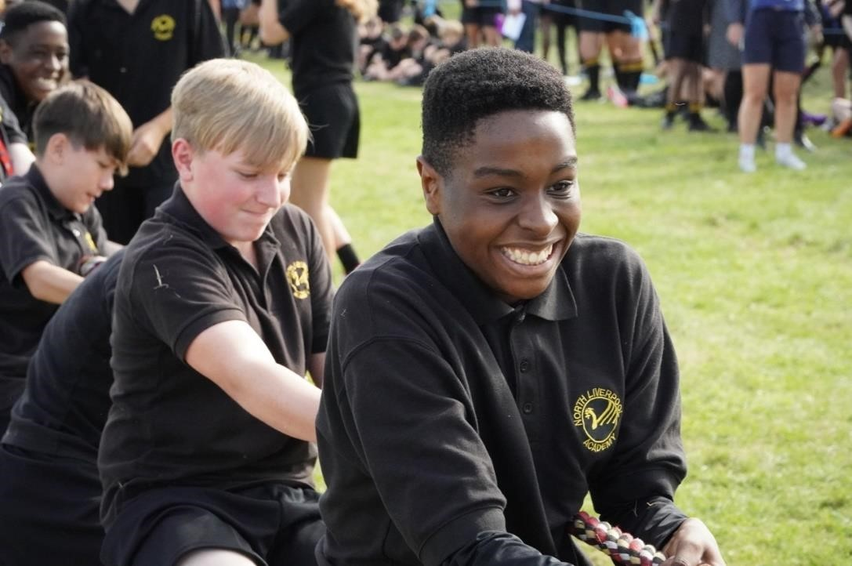

Our Learning Journey shows how our topics build upon each other and our students experience a wide variety of themes in order to broaden their learning experience:

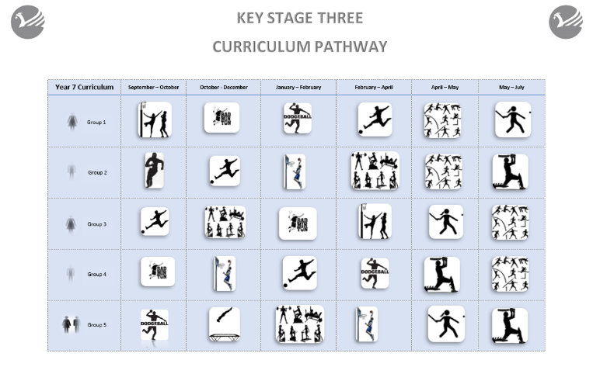

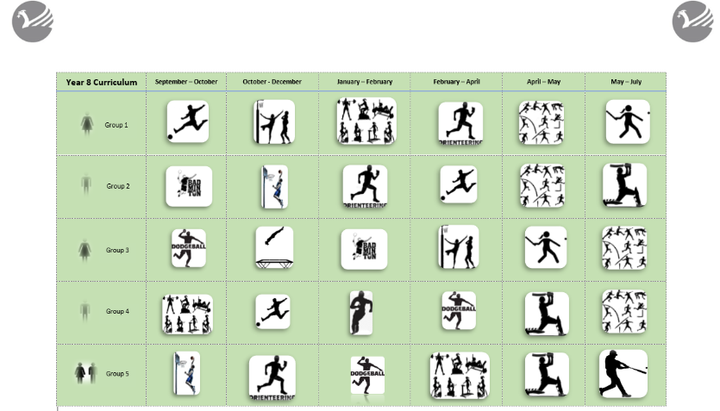

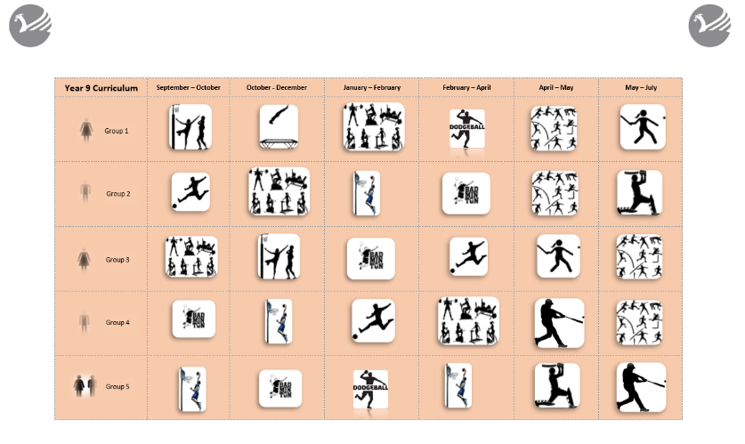

The curriculum pathway our students follow is tailored based on our sets to ensure that every student is challenged and engaged within their PE lessons. It is our aim to ensure that our curriculum is designed to capture students’ interest and raise engagement not only in lesson, but also outside of the curriculum through external agencies and enrichment clubs.

All Three Years
Football, Dodgeball, Cricket, Netball, Rounders, Softball, Health Related Fitness, Athletics, Badminton, Trampolining, Basketball
Year 7
Badminton
Trampolining
Rounders
Basketball
Rugby
Cricket
Gymnastics
Health Related Fitness
Year 8
Orienteering
Sport Education
Basketball
Badminton
Cricket
Problem Solving
Rowing – with Merseyside Rowing Club
Year 9
Sport Education
Problem Solving
Orienteering
Health Related Fitness

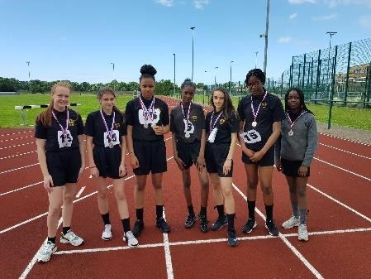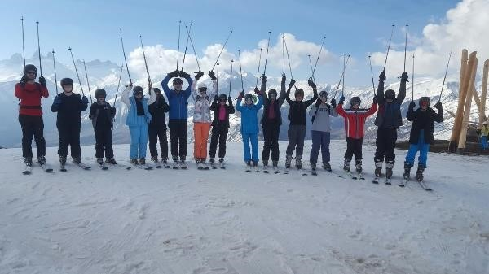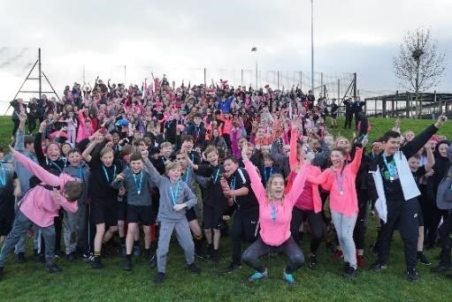

Learning through Experiences in PE
In order to enhance the provision of PE beyond the curriculum, our students benefit from the following experiences:
- Merseyside Rowing Club – working with students to develop their technical and tactical performance in rowing at Liverpool Victoria Rowing club. The programme provides opportunities to compete a local, regional and national level.
- School teams and fixtures – students who represent our sports teams will have the experiences of competing in leagues and tournaments both at local, regional and national level
- Inter-house Tournaments – every student gets to experience competition within their house teams every term in variety of different sports and activities.
- Enrichment Clubs – students have a variety of different sports clubs on after school which they can take part and compete against other schools or participate for fun and to keep active.
- Active in Mind – developing students’ abilities to use practical activities to support mental health with a focus on team work, emotions and mindfulness.
- Healthy Lifestyle Champions – working with students to stress the importance sport and physical activity has on leading healthy lives.
- LFC Foundation – support our curriculum experiences offered to students through offering sport leadership course, inclusive football sessions for SEN students, girls football development.
- Liverpool Schools Sports Partnership (LSSP)– We have developed and forged strong links with LSSP allowing our students not only to participate in an array of sporting events but also host several events across the year which include working with primary schools.
- School Ski Trips – students have the opportunity to join our school Ski Trips.
- Participation in charity events – Santa dash raising money for the community food bank. Blue run raising awareness for Joseph Lappin. Race for life raising money for cancer research.

