
Key Stage 3 Curriculum

Performing Arts
Key Stage 3 Performing Arts explores different styles and genres of Performance work, touching on both disciplines of Dance and Drama. Students learn about existing Performance work and practitioners, analysing their creative intent and audience impact.
Students participate in workshop style exploration, in which collaboration and reflection are key, they create their own practical outcomes based on the knowledge and skill base that they refine.
The curriculum is differentiated within topics and allows students to gain confidence talking to and with others formally. They are equipped with the tools to be an effective and informed performer, and they are nurtured so that they have the confidence to be creative and experimental in their practical outcomes.
Our students enjoy the opportunity to reflect upon real world scenarios and present their viewpoint in an engaging and innovative way.

Beyond the curriculum, our students are invited to participate in a multi-faceted Enrichment programme, that provides opportunities for skill development and community experience beyond the classroom. Students of all ages work alongside one another in an ensemble fashion, reaching out to the community with innovative, relevant, and challenging projects. Accreditation in LAMDA, and Arts Award provide students with professional standard qualifications beyond their curriculum and create opportunities for students to create and innovate within the community. North Liverpool Academy run both Drama and Dance companies, in which students are trained to be accomplished performers equipped for industry.

Our Learning Journey shows how our topics build upon each other and our students experience a wide variety of themes to broaden their learning experience:

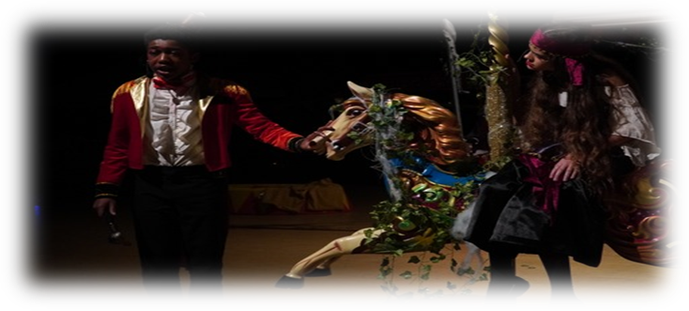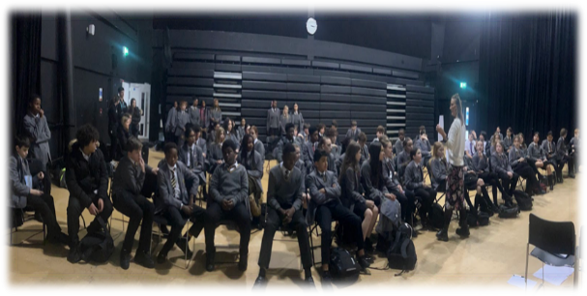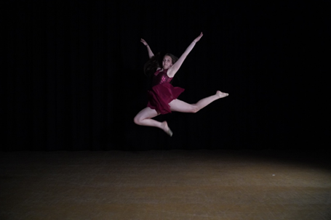

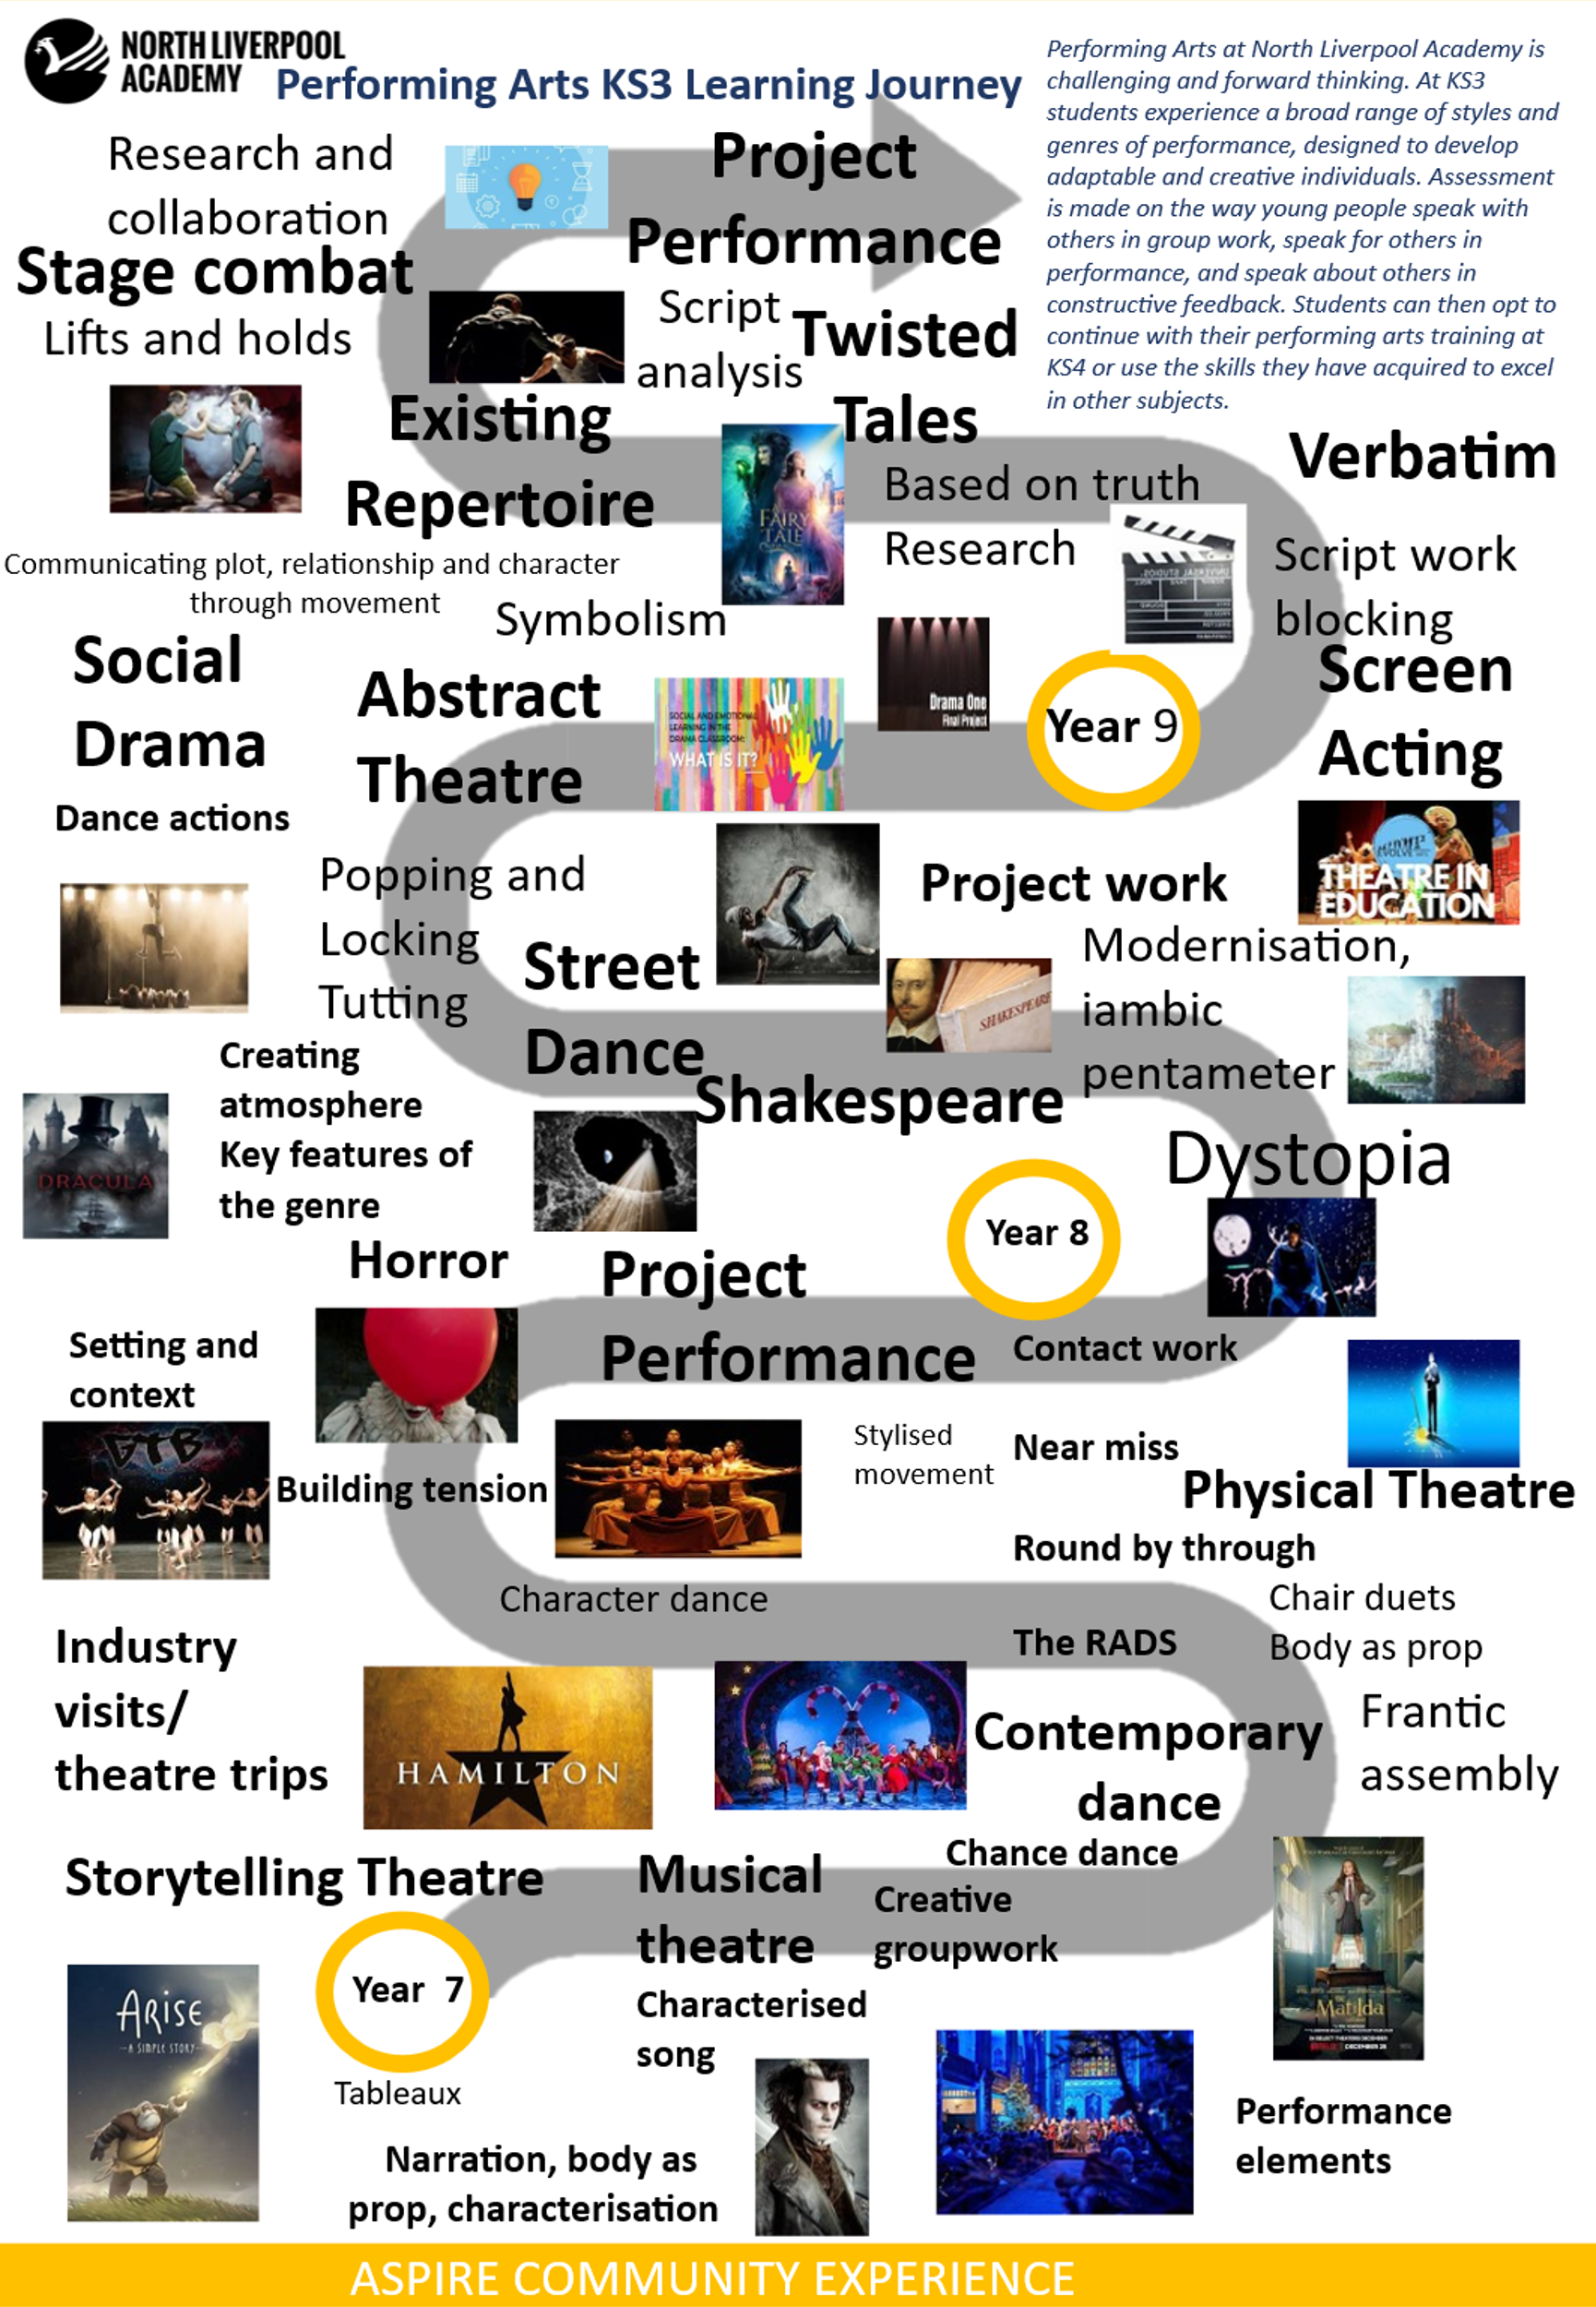

Our curriculum is broad and varied and covers many different areas of Performing Arts:
Year 7
Storytelling Theatre
Musical Theatre
Contemporary Dance
Genre
Physical theatre
Project work
Year 8
Dystopia
Shakespeare
Street Dance
Social Drama
Abstract Theatre
Project work
Year 9
Screen acting
Verbatim Theatre
Twisted tales
Existing Repertoire
Physical theatre
Project work

Learning through Experiences in Performing Arts
Aiming to enhance the provision of Performing Arts beyond the curriculum, our students benefit from the following experiences:
- Edge Acting Experience
- Bold Dance Company
- Performance Story Telling
- Christmas Show
- Summer show
- Winter Wonderland
- LAMDA
- Stage Combat Workshop
- Casting Director Visits
- Theatre Trips
- Primary Schools Performances
- LSSP dance competitions
