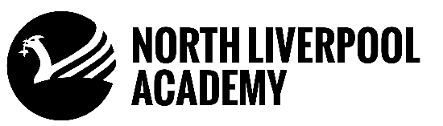
Key Stage 3 Curriculum
Science
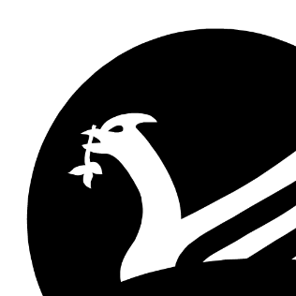
Science has changed the way that we live and while studying key stage 3 science at North Liverpool Academy students gain an understanding of the importance of science in their everyday life. Whether students are going to follow a career in science or whether they will require skills in order to follow alternative pathways, science is key to understanding and modelling the world around us.

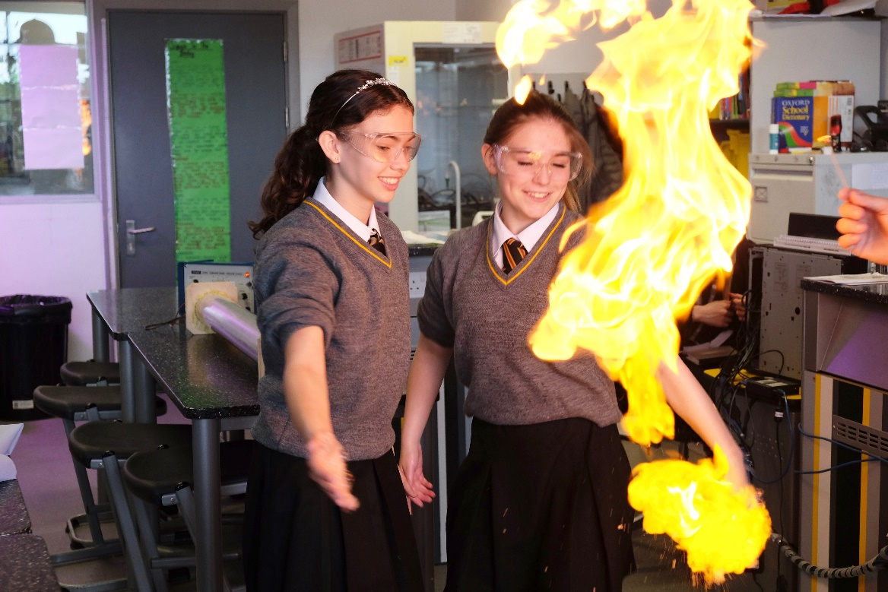

Key Stage 3 Science at North Liverpool Academy allows students to learn about the fundamental knowledge required to be successful throughout their school life. It also equips them with the skills to become the scientists of the future. Our Year 7 curriculum is designed to establish a comprehensive foundation in key scientific concepts, including cells, energy, and atomic structure. This core knowledge prepares students effectively for the thematic learning journey they will undertake in Years 8 and 9.
We employ a thematic learning approach to make science engaging and accessible to all students. These themes are rooted in tangible, real-world science that students encounter daily. Furthermore, we strategically align these themes with the seasons to enhance relevance and impact. For instance, we explore 'carbon zero homes' as temperatures drop in winter and teach students how to 'grow their own' plants during the spring. It is our aim to instil high aspirations into every student so that they leave Year 9 engaged, enthused and resilient; ready for the next steps of their academic journey.
We endeavour to provide a fully inclusive KS3 curriculum which has a strong emphasis on problem solving, with stretch and challenge opportunities integrated throughout. It is our aim to ensure our students develop a deeper understanding of scientific principles.

Our Learning Journeys shows how our topics build upon each other, and our students experience a wide variety of themes in order to broaden their learning experience:
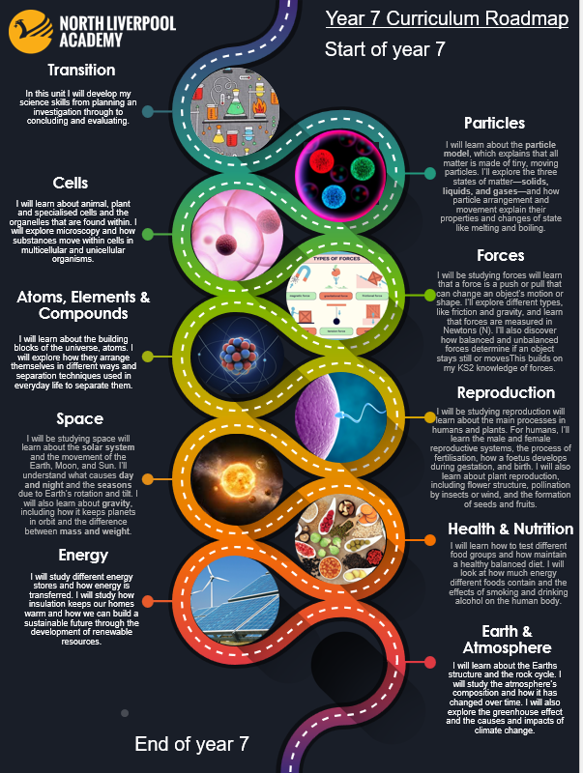

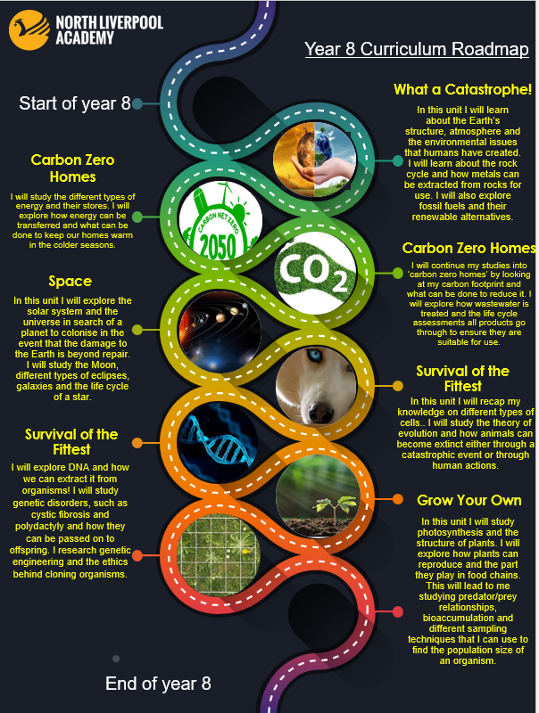

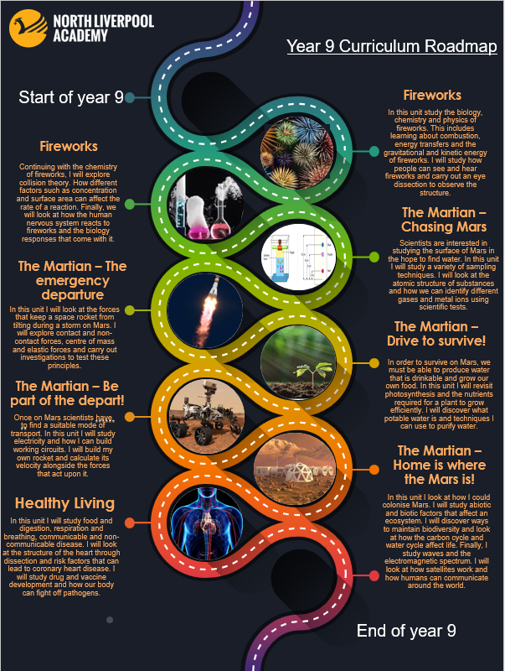

The curriculum is differentiated within topics in order to match the pace and challenge with the needs of the students and their learning journey will cover the following key themes:
Year 7
Transition
Particles
Cells
Forces
Atoms, elements and compounds
Reproduction
Space
Health & Nutrition
Energy
Earth & the Atmosphere
Year 8
What a catastrophe!
Carbon Zero homes
Space
Survival of the fittest
Grow your own
Year 9
Fireworks
The Martian project
Healthy living

Learning through Experiences in Science
In order to enhance the provision of Science beyond the curriculum, our students benefit from the following experiences:
Firework Display

Winter Wonderland Snow Displays and Sublimation Experiments
Survival of the Fittest – Eggucate Chicks hatching
Electric Car – Polestar Visit
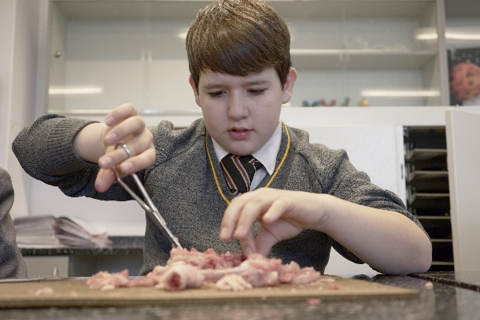
CORE Movie Experience
Planetarium Visit
Animal Show
Farm Urban Workshop
Building and Launch Rockets Project
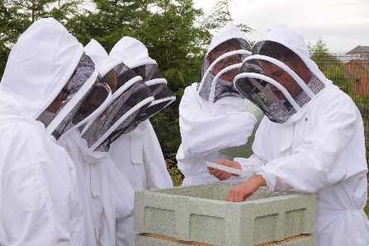
Medical Mavericks
STEM week
Bee Project

